* DEPLOYING SPRINGBOOT
* Wht is task?

Deploy the springboot application in AWS

* Tools or software?
* AWS Management Console
* Springboot
* AWS CLI
* IDE/ECLIPSE
* In aws which services?
* Elastic Beanstalk
* IAM also To create the ROLE
* Package the app
* Create elastic Beanstalk application
* Upload and deploy the app
* Configure the environment
* Monitor and Manage
* What is the procedure?
* 1st Create springBoot Application
* 2nd U have to Build maven for this Application
* Create Environment for the ELASTIC Beanstalk
* CREAte ROLE for the IAM

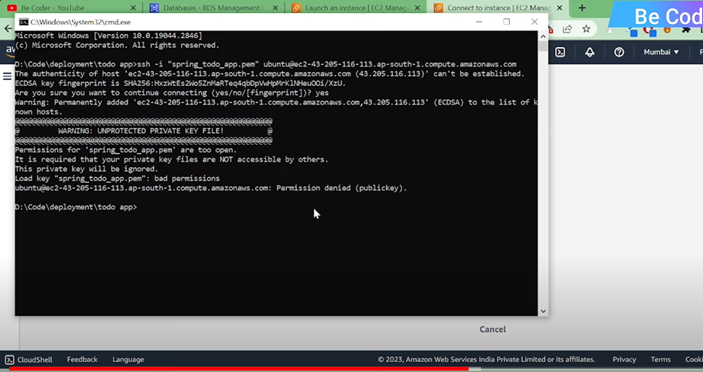

* **Create Database in RDS**
* **Get Our remote Database and connect to our Project**
* **Create EC2 Instance and push our spring boot there**
* **Get our EC2-springboot-endpoint and connect to our ReactApp**
* **Deploy Our ReactAPP on S3**
* **What is AWS ELASTIC Beanstalk?**

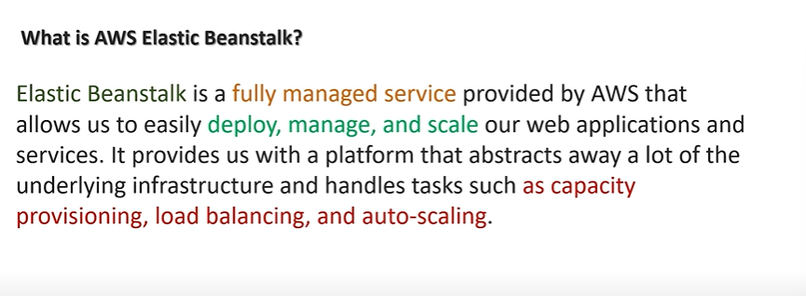

* **Ull provide ur Applcation link to the AWS Elastic Beanstalk**
* **THIS EBeanstalk will deploy ur application on the AWS Cloud**
* **By doing this it will reduce the insfrastructure that we will have to manually.**
* **And it handles tasks such as capacity, Load Balancing, AutoScaling**
* **Lets Look at what happen internally when we launch an application in elastic beanstalck**
* 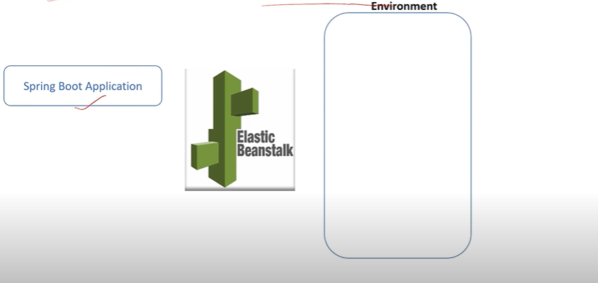
* 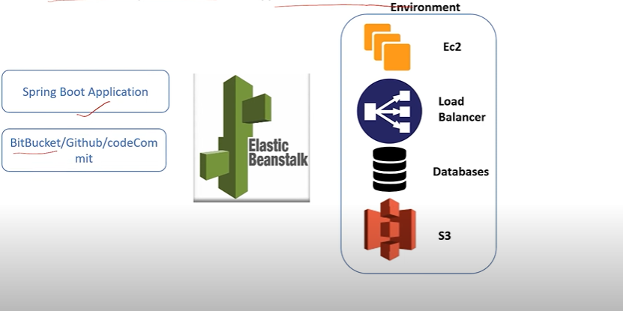

**REQUIREMENTS:**

* **AWS account**
* **IDE sts/eclipse**